

**Wayfair Campaign Product Report Data Analysis**

Yilin Huang

**Content:**

**1. Introduction**

Sponsored Products is Wayfair’s newest media opportunity, a program to offer a paid solution for suppliers seeking greater visibility of their products on wayfair.com.

It is an opportunity for boosted product placement on-site through a proprietary bid management system. Winning products will be pushed into high-performing slots on browse pages, positioned directly in front of customers.

The goal for Well Woven is to understand that what kind attributes for products will satisfied the target customers and will have the potential to boost the sales on the Wayfair in the future.

**2. Problem_Statement**

In order to find out what kind of attributes for products will have good return performance in Wayfair, the Wayfair Competitors Analytics scraped dataset from Wayfair official website to analyze the competitors’ products performance and to gain insights to support decision making process for future new campaigns.

**3. Data_Description**

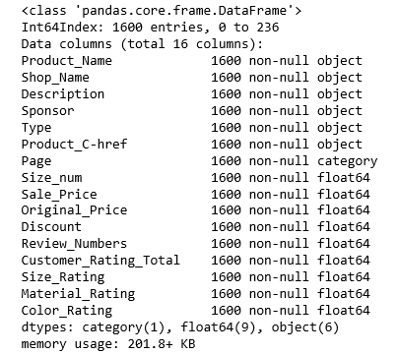

# Dataset Description

This project dataset was scraped from Wayfair official website include the information for the Area Rug (size 5x8, 8x11) and all sizes for Hallway/Doormat/Kids/Round/Shag/Oriental. This dataset has 1600 records (products information) and 16 features.

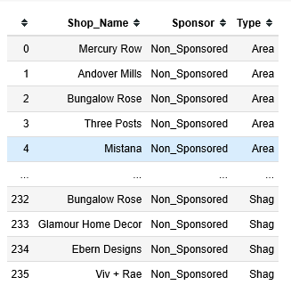

# Categorical Data

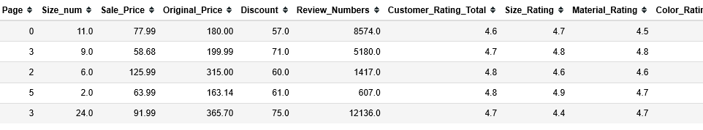

# Numerical Data

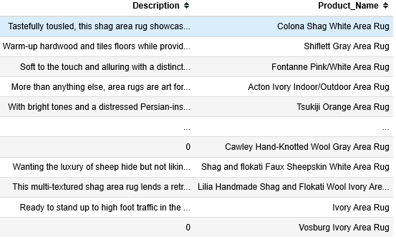

# Text Data

There are three different types of features in this dataset, including categorical data, numerical data and text data.

For the reason that we can not get the most important data such as sales and returns for our competitors’ products in the website, this project regards reviews for different product on Wayfair that we could scrape from the website as our target to evaluate the products’ performance.

**4. Exploratory Data Analytics**

**4.1 Sponsor Product Analytics**

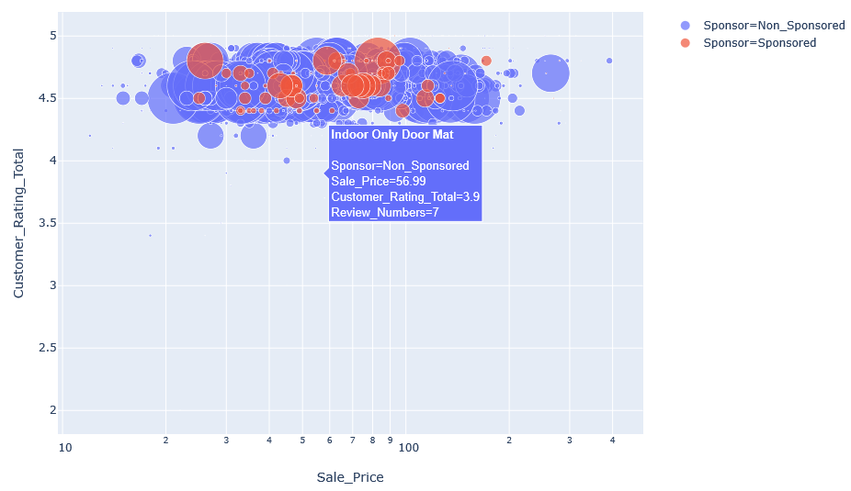

**Description:**

This chart describes the products information about sale prices (X axis), customer rating (Y axis), sponsor or not (color) and review numbers (Size).

**Question:**

Does sponsor products have higher reviews than non-sponsor products?

**Answer:**

No.

From this chart, we could see that the red bubbles are much smaller than the blue bubble, and from the information that Wayfair (<https://www.rsgsales.com/new-blog/wayfairsponsoredproducts>) provided, the sponsored product usually focus on:

1. New products
2. Best Sellers
3. Products you want to gain more traction
4. Products that have great merchandising,
5. Products with good reviews
6. Products that are in-stock

These products usually are regarded by our competitors as products have will good performance in the future.

**Insights:**

1. We could find that the big bubbles usually scatter around the review 4.5. We may assume that the people will prefer to buy products with good rating and then good rating attract more customers.

2. Sales prices for competitors scatter around the price between $20 and $130 in the first 5 pages for these different products.

**4.2 Competitors sponsored products Analytics**

This analytics will dig more into the competitors’ products with sponsor to find out what kind of products they selected to sponsor.

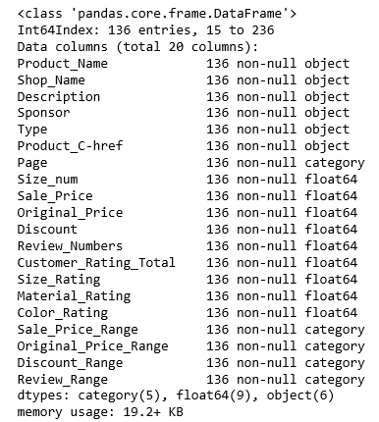

After filtering out the product without sponsor, the dataset got 136 records which is around 8.5% (136/1600) total records in this raw data.

From this small dataset, we could try to explore products that preferred for our competitors to sponsor.

**4.2.1 Sponsored Shop Name**

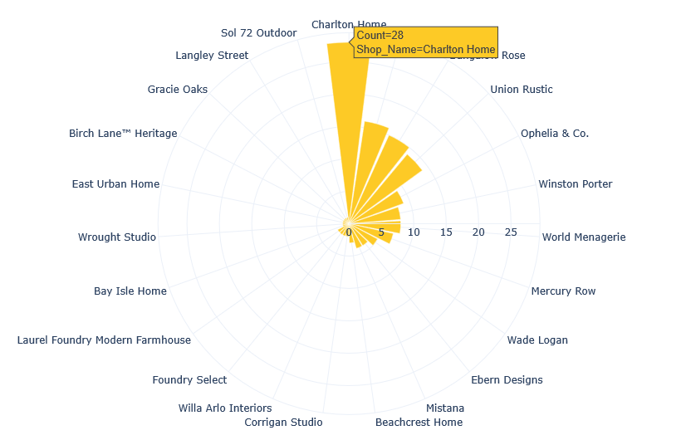

**Description:**

This chart shows that how many products sponsored in different shop.

**Question:**

What kind of shops preferred to be sponsored by our competitors?

**Answer:**

Charlton Home (28 counts)

**Insights:**

Charlton Home is a shop sells traditional American design furniture. Maybe in the future, we could sponsor the products which belong to traditional pattern.

**Appendix:**

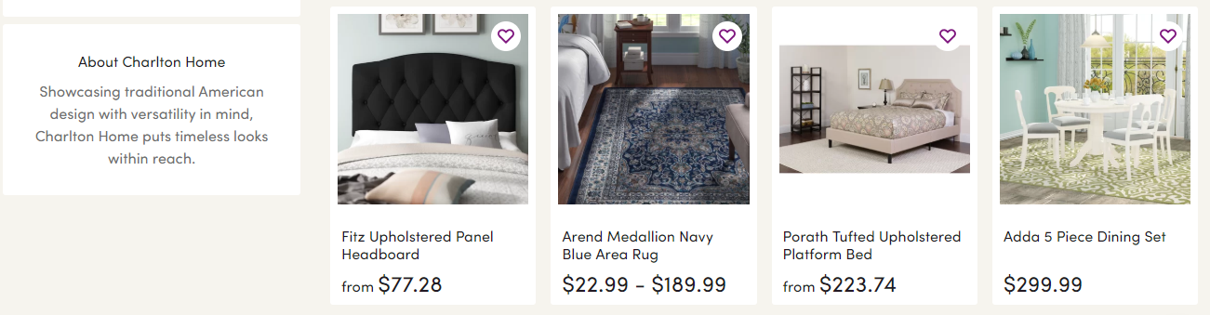

<https://www.wayfair.com/brand/bnd/charlton-home-b36986.html?rtype=9&redir=charlton+home>

**4.2.2 Sponsored Type**

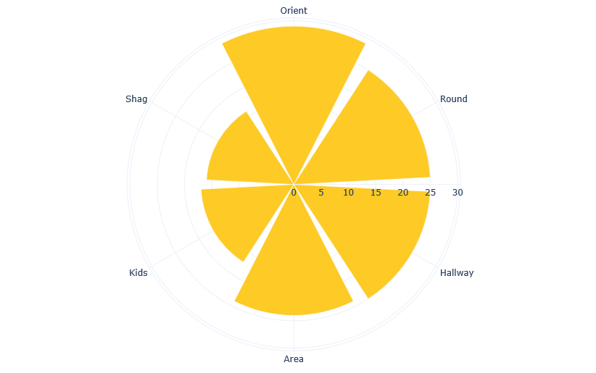

**Description:**

**Question:**

What kind of Types prefer by the customers in Wayfair?

**Answer:**

Orient/Round/Hallway/Area

Less Shag/Kids

**Insights:**

From this chart, we could find that our competitors may not prefer to sponsor the products which are belongs to Shag and Kids.

**Appendix:**

Shaggy Rugs

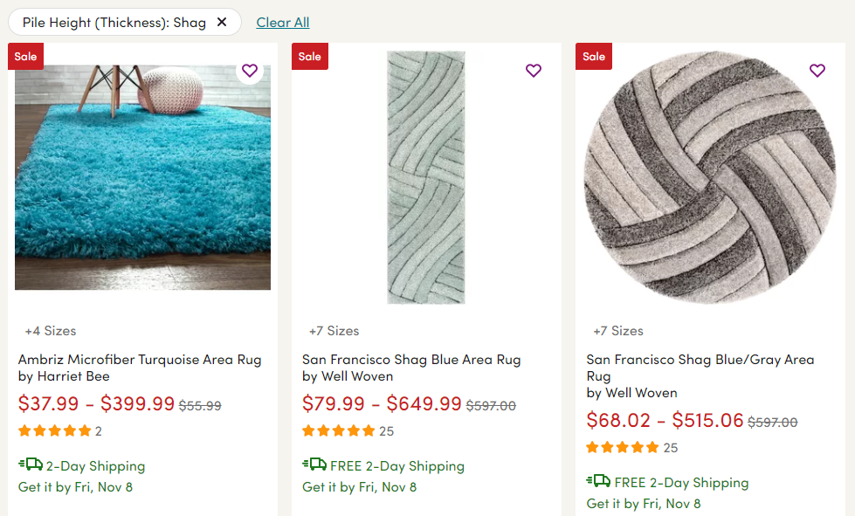

<https://www.wayfair.com/keyword.php?keyword=shaggy+rug&command=dosearch&new_keyword_search=true&class_id=>

Kids Rugs

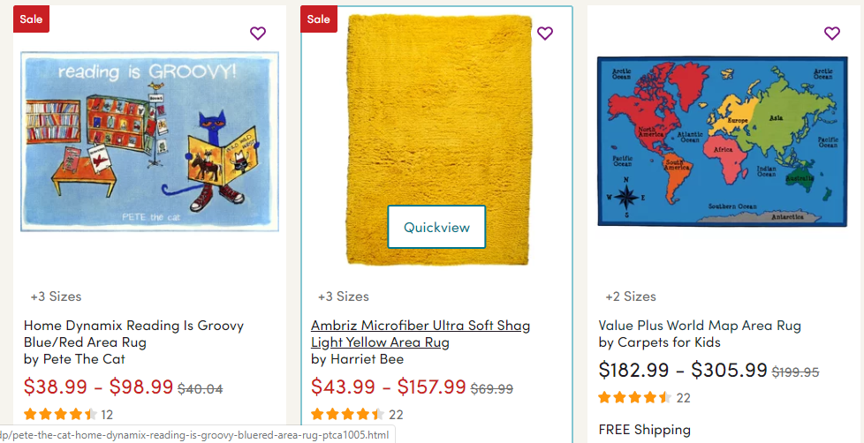

<https://www.wayfair.com/rugs/sb0/kids-rugs-c1834363.html>

**4.2.3 Sponsored Page**

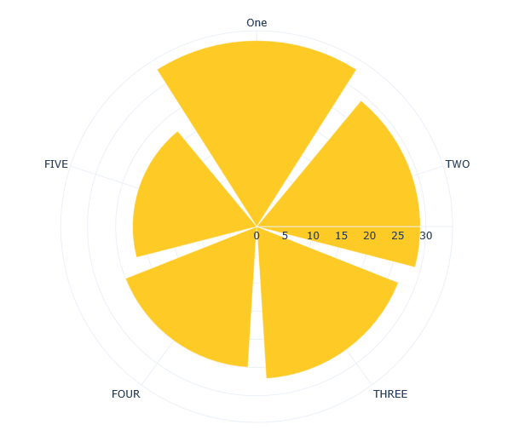

**Description:**

This chart describes how many products sponsored in different pages?

**Question:**

Does our competitor will sponsor the product rank in the higher?

**Answer:**

No.

From this chart, we could observe that these product scatter equally in different page, they do not have the preference to sponsor the products in different page.

**Insights:**

We could assume that they may select the products they think will boost the sales and for the potential future in the higher rank, but not have good performance currently.

**4.2.3 Sponsored Discount Range**

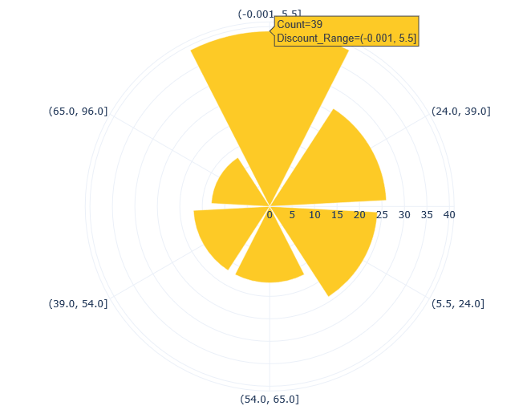

**Description:**

This chart describes sponsored product discount range.

**Question:**

What discount ranges for products are preferred to be sponsored by our competitors?

**Answer:**

(-0.001,5.5]

**Insight:**

From this chart, we could observe that our competitors do have the preference for the discount range to sponsor and these products do not have too much discounts.

**4.2.4 Sponsored Size num**

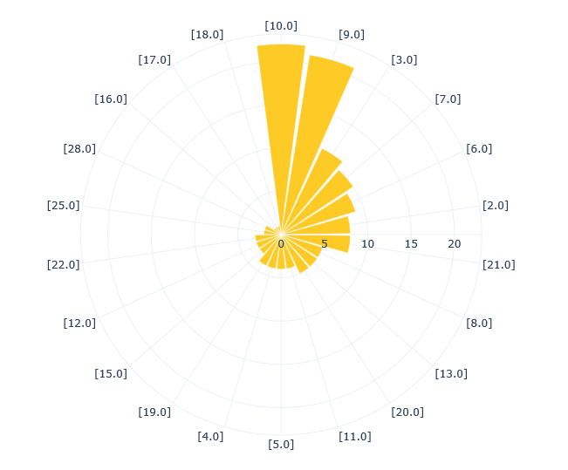

**Description:**

This chart describes sponsored product size num range.

**Question:**

How many sizes for products are preferred to be sponsored by our competitors?

**Answer:**

10, 9

**4.2.5 Sponsored Sale Price Range**

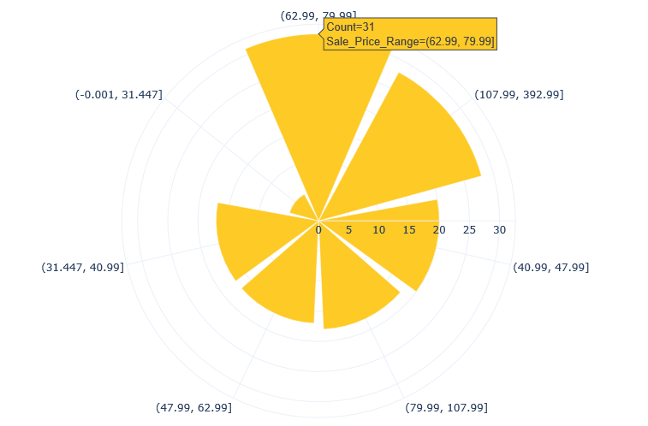

**Description:**

This chart describes sponsored product sale price range.

**Question:**

What is the price range for products are preferred to be sponsored by our competitors?

**Answer:**

(69.99,79.99] / (107.99,79.99]

**Insight:**

It difficult to tell that whether or not they have the preference of the price range to sponsor. But our competitor barely to sponsor the lower price product.

**4.3 Page/Type/Reviews Analytics**

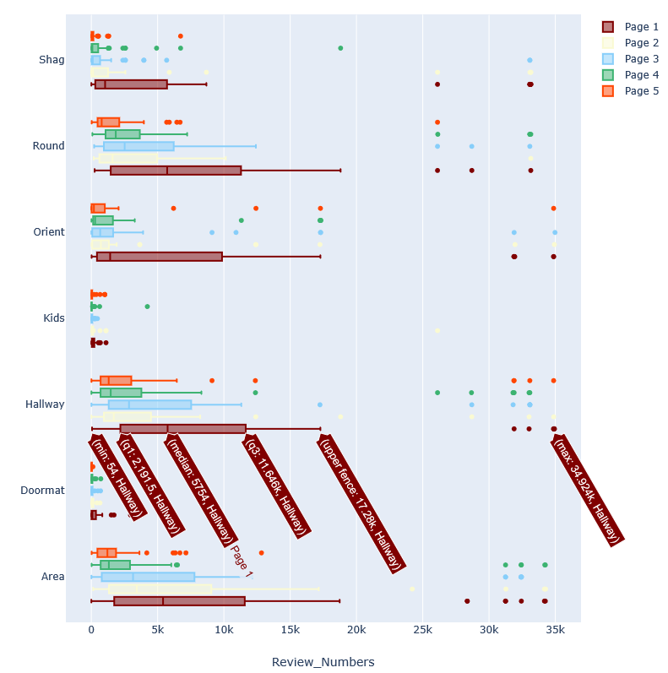

**Description:**

This boxplot includes the information about page, Type of product and Review Numbers.

**Question:**

Q1： Does page rank higher means have higher reviews?

Q2： What kind of type of product have higher reviews?

**Answer:**

Q1: Yes. The higher rank means customer’s preference. If you sponsor the product does not have prefer by customers, the rank will be lower even if you invest money on this product.

Q2: Area/Hallway/Round

**4.4 Shop Name Analytics**

# 

**Description:**

This boxplot describes the review distribution of review for different shop.

**Question:**

Which shops have higher review?

**Answer:**

Andover Mills/Mistana/Hashtag Home

**Insights:**

The Andover Mills provide budget friendly furniture, At Mistana, provice Pacific coast–inspired boho furniture and Charlton Home is a shop sells traditional American design furniture.

From the information above, we may assume that our customers in wayfair prefer the product which are boho and traditional style with lower budget.

**Appendix:**

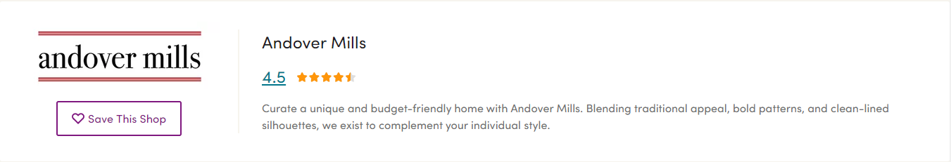

<https://www.wayfair.com/brand/bnd/andover-mills-b30808.html>

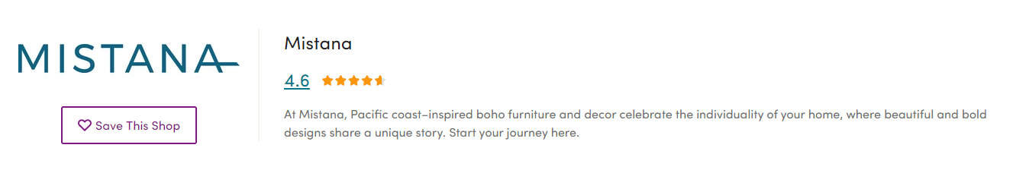

<https://www.wayfair.com/brand/bnd/mistana-b44356.html>



<https://www.wayfair.com/brand/bnd/charlton-home-b36986.html?rtype=9&redir=charlton+home>

**4.5 Sale_Price Analytics**

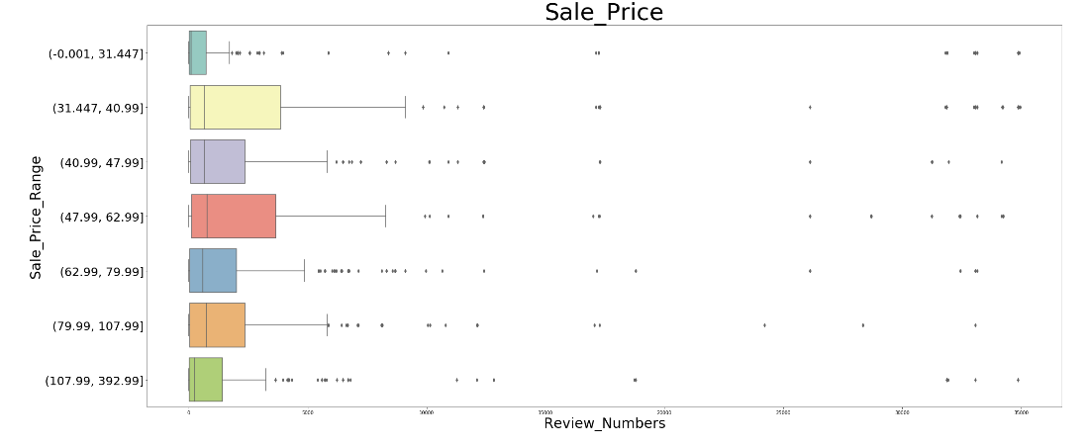

**Description:**

This boxplot describe the review for different sale price range.

**Question:**

What kind of pricing range prefer by the customers in Wayfair?

**Answer:**

(31.447, 40.99]') / (47.99, 62.99]')

**Insights:**

We could observe from this chart that the price setting in the top 5 pages are not very high, from$ 0 to $400 around. The customers may prefer rugs not too much expensive around $30 to $60.

**4.6 Discount Analytics**

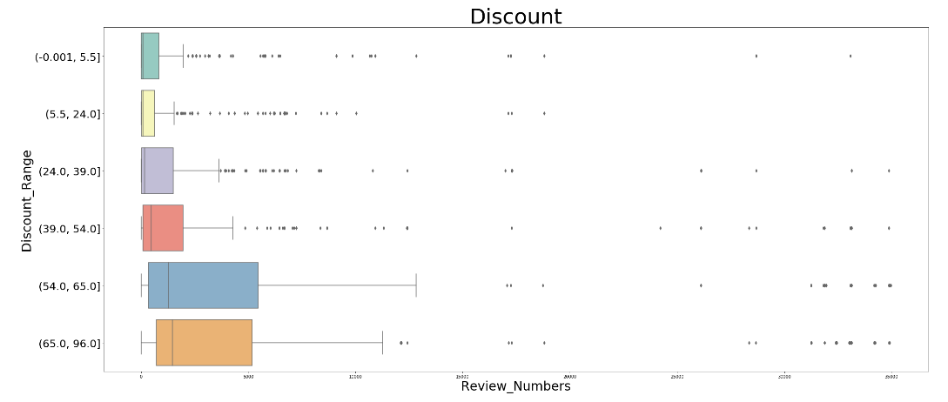

**Description:**

This boxplot describes the reviews for discount range.

**Question:**

What kind of discount range prefer by the customers in Wayfair?

**Answer:**

(54.0, 65.0]/ (65.0, 96.0]

**Insights:**

The customers may prefer the products shows with higher discount. For the reason that, the higher discount for the product will make them feel pay less money buy the good products.

**4.7 Discount Analytics**

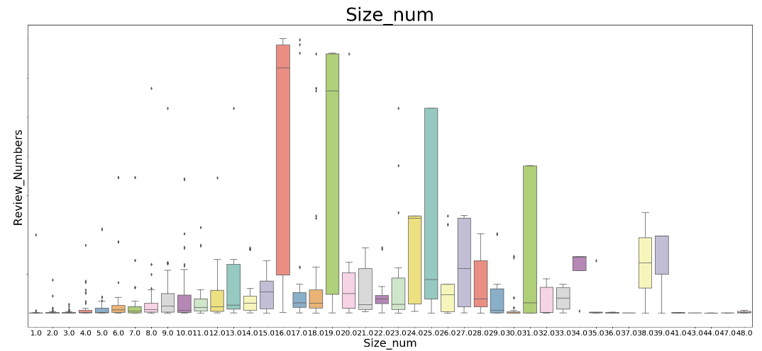

**Description:**

This boxplot describes the reviews number for different sizes for products.

**Question:**

How many sizes for products prefer by the customers in Wayfair?

**Answer:**

16/19

**Insights:**

Customers may prefer the products that could provide them more choice for the size. But doesn’t mean the more the better, sizes better to be 16 and 19.

**5 Text Analytics**

**5.1 Valuable keywords**

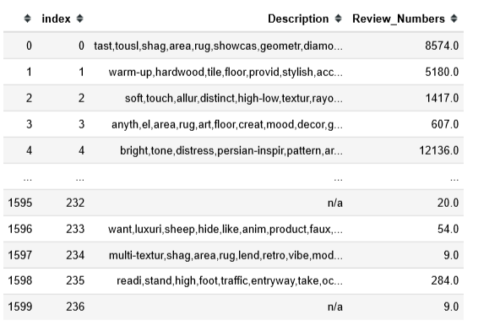

The product description has been tokenized, filtered out stopwords and punctuation, conducted stemming and lemitization (<https://nlp.stanford.edu/IR-book/html/htmledition/stemming-and-lemmatization-1.html>)

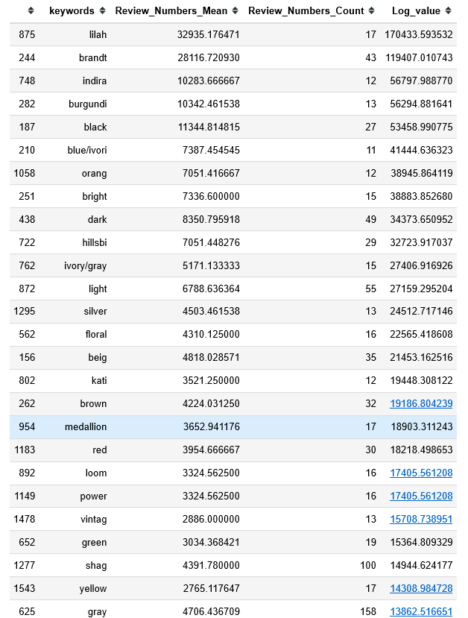

This table shows valuable words for the product description. Each word I took its average review value and count how many times this word appeared in the dataset. For the Log_value, I punished the words appeared too much time on the dataset to avoid the table to appear non valuable words appear too much time on the description and with higher value such as rug.

The words with higher count and Log_Value are the most valuable words.

**Insights:**

From this list, we could observe what kind of rug type/color/words for products may have potential have higher reviewr.

Rug Type: Lilah/Brandt/Indira/Burgundi/hillsby

Color:Black/Blue/Ivory/Orange/Bright/Dark

Other words: Power-Loom

Make customer feel like the products are durable. We could use this word more often to describe our products in future.

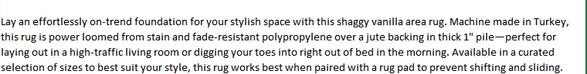

<https://www.wayfair.com/>

**5.1.2 Words Cloud**

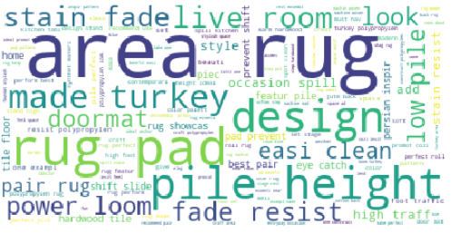

Description: This wordcloud describe words that our competitors usually used to describe their product.

Insight: Except Area rug, made turkey,design, words to describe products that how it look like and come from. They also use power-loom, resist, easy clean to emphasize the product’s function with good quality.

**5.1.3 Model Building (Optional)**

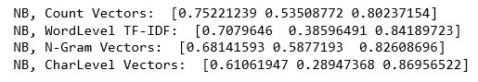

Deployment:

This model build based on the dataset come from out competitor. The first model has better result, and the accuracy is 75%, 53% and 80%. For the future product description, we may deploy this model to know that whether or not the product description will have Weak/Neutral/High reviews.

1. **Limitations:**

For the sponsored product analytics, we only get 136 records, this dataset is too small to generate strong conclusion that what kind of product that our competitors may prefer to sponsor.

**7. Results**

Assume that the data did not have the limitation, we could get a clear direction that what kind of products that our competitors may prefer to sponsor, what kind of products may satisfy our target customers.

what kind of products that our competitors may prefer to sponsor:

1. Traditional Pattern Rug
2. Type: More Orient/Round/Hallway/Area

Less Shag/Kids

1. Discount Range: (-0.001,5.5]
2. Size Num: 10, 9
3. Sale Price Range: (69.99,79.99] / (107.99,79.99]

what kind of products may satisfy our target customers:

1. Type: Area/Hallway/Round
2. Attributes of product from Shop Name Analytics:

product which are boho and traditional style with lower budget

1. Price: prefer rugs not too much expensive around $30 to $60.
2. Discount Range: (54.0, 65.0]/ (65.0, 96.0]
3. Size Num: 16/19
4. Rug Collection(?): Lilah/Brandt/Indira/Burgundi/hillsby
5. Color: Black/Blue/Ivory/Orange/Bright/Dark
6. With description Word: Power-Loom